Press release

Intelligent sensor cable with SmartCore Technology
Leuze electronic presents an intelligent sensor cable with SmartCore Technology that improves machine and system availability.
Owen, 9. February 2018 - With the new SmartCore cable, Leuze electronic presents an interesting highlight at the Hannover Messe 2018 trade fair especially for applications with moving cables, e.g., in robots or with handling axes. The cable contains an additional, special sacrificial cable that fails at approximately 80% of the possible movement cycles. To evaluate, the sacrificial cable is bridged with the supply voltage and, if the core breaks, gives early warning of the impending end of the cable's service life. Unplanned system downtime caused by cable breakage can thus be effectively prevented, and the sensor cable at risk of breaking can be replaced during the next scheduled maintenance cycle. The SmartCore Technology thereby contributes to increased system availability.
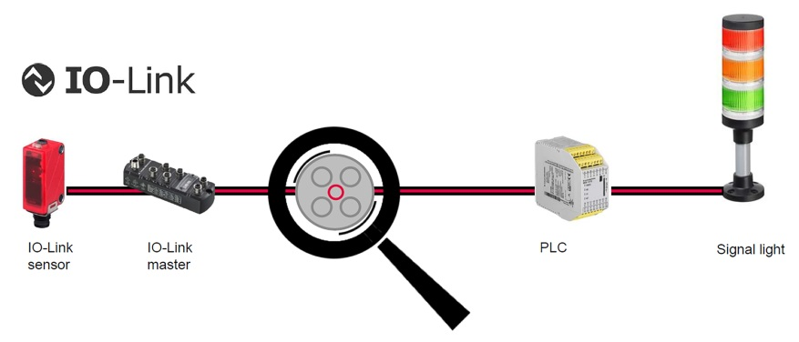
Figure: Intelligent sensor cable with “SmartCore Technology“

Contact address:
Leuze electronic GmbH + Co. KG
In der Braike 1
73277 Owen
Ph.: +49 7021 573-116
Fax: +49 7021 573-199
E-mail: info@leuze.com
Web: www.leuze.com

Leuze electronic is one of the world's innovation leaders in optical sensors and is internationally known as a leading manufacturer and solution provider in electrical automation. Its main focus is on the areas of intralogistics, packaging industry, machine tools and automotive industry as well as medical technology. The product range includes switching and measuring sensors, identification systems, solutions for image processing and data transmission and also occupational safety components and systems. Founded in 1963, the company, with headquarters in Owen (Germany), possesses specific application know-how as well as comprehensive industry knowledge. More than 1200 employees at 22 locations are involved in development, production, sales and service – supported by more than 40 sales partners around the world. Innovative product developments, tailor-made complete solutions and an extensive range of services stand for the "Smart Sensor Business 4.0" at Leuze electronic.
Press inquiries
Leuze electronic GmbH + Co. KG, Owen
Martina Schili, Phone +49 7021 573-116
martina.schili@leuze.com, www.leuze.com

